You are working as a Devops Administrator. You’ve been tasked to deploy a multi-tier application on Kubernetes Cluster. The application is a NodeJS application available on Docker Hub with the following name:

*devopsedu/employee*

This NodeJS application works with a mongo database. MongoDB image is available on DockerHub with the following name:

*mongo*

You are required to deploy this application on Kubernetes:

* • NodeJS is available on port 8888 in the container and will be reaching out to port 27017 for mongo database connection
* • MongoDB will be accepting connections on port 27017

You must deploy this application using the CLI.

Once your application is up and running, ensure you can add an employee from the NodeJS application and verify by going to Get Employee page and retrieving your input.

**Hint:** Name the Mongo DB Service and deployment, specifically as “mongo”.

**Solution:**

Build a mongodbDeployment.yaml for Mongo DB, with the following code.

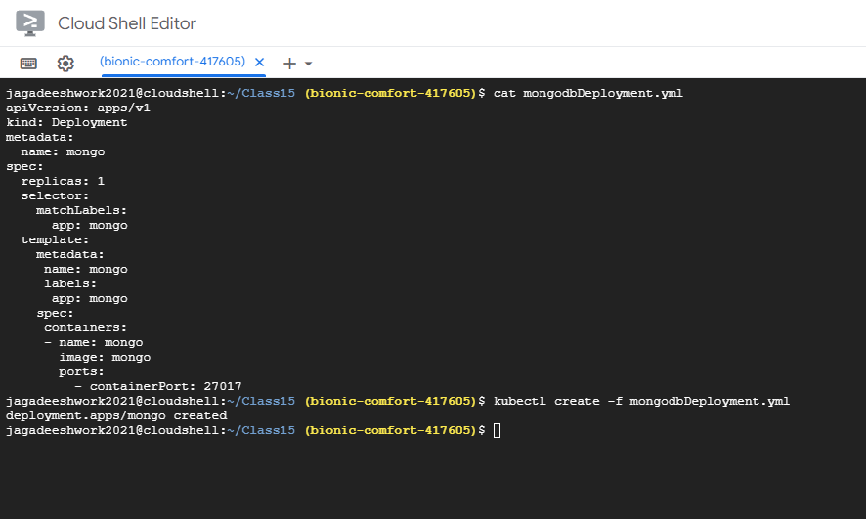

Created service for this deployment mongodbDeployment as per following code :

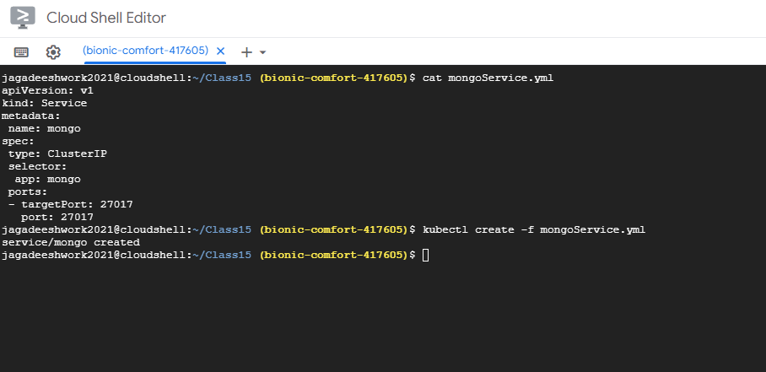

Build a nodejsapp.yaml for front end website, with the following code.

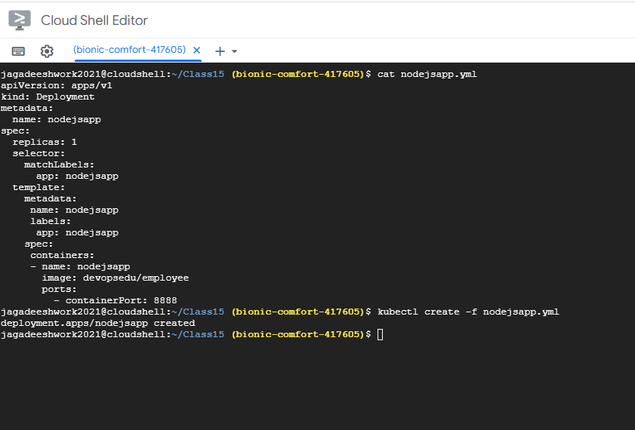

Created a service for this deployment nodejsapp as per following code :

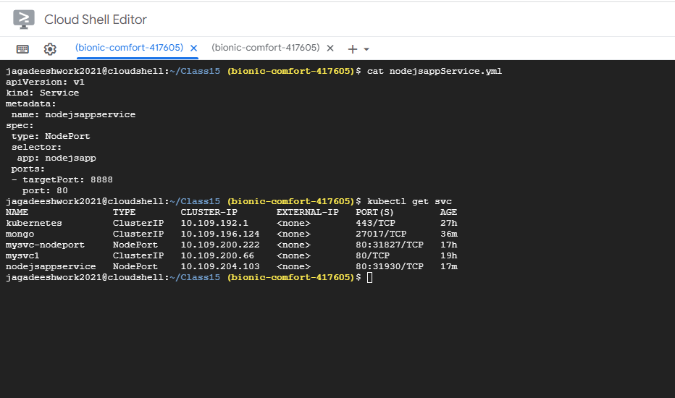

To get the port number, where your front end will run.

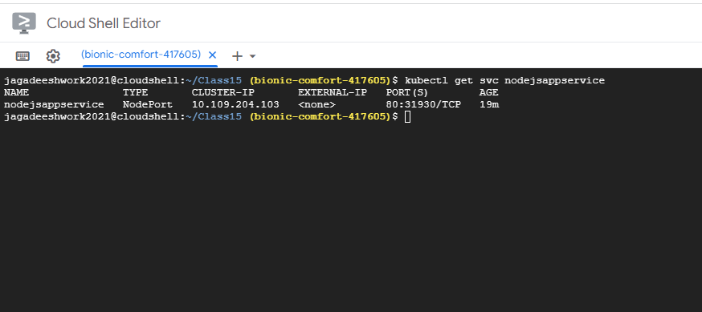

Checked our website’s connectivity with the database